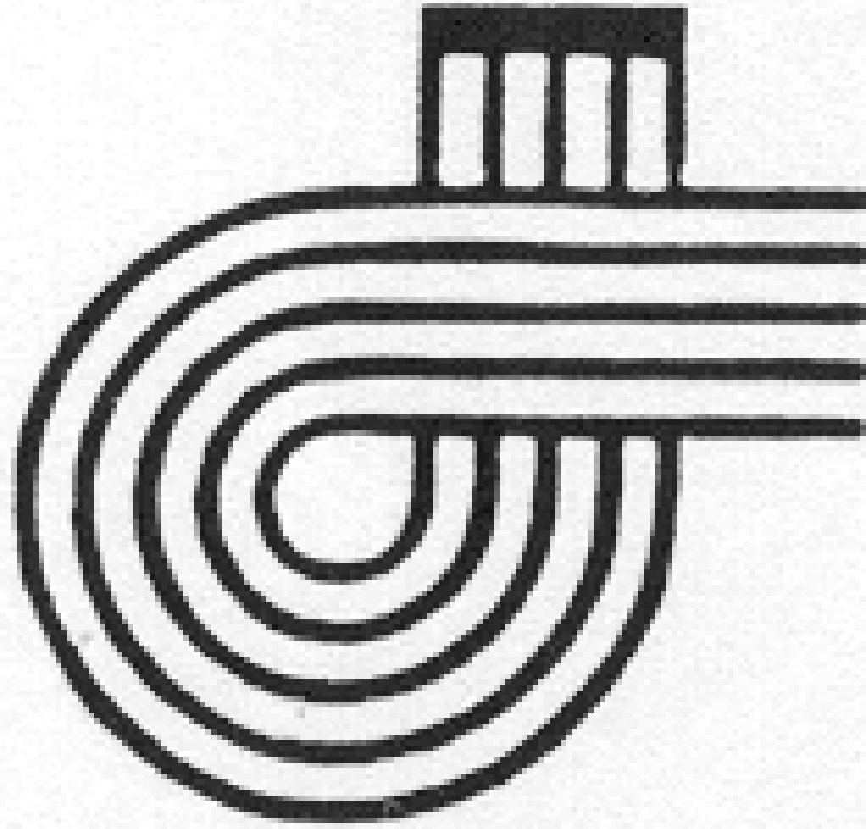
CONTEMPORARY SHOWCASE MISSISSAUGA
2025 ENTRY FORM
NOVEMBER 22 & 23, 2025

Entries must be received by October 15, 2025 Late entries will not be accepted.
Please consult the Contemporary Showcase Syllabus for the rules and class numbers.
Available at www.acnmp.ca
Preference of day and time must be noted on the entry form. No changes will be considered after entries are received by the registrar.
Please print clearly to complete the following. Submit one separate entry form for each solo or ensemble.
Entrant Information
Name
Address
City Province Postal Code
Telephone Email ___
Teacher / Conductor / Professor Information
Name
Address
City Province Postal Code
Telephone Email ___

CLASS  NO. | TITLE(S) | COMPOSER | INSTRUMENTATION | DURATION
Special request for day and time:___________________________________________
Please list names of additional performers: | Entry Fee (see reverse): | $ _____________
_____________________________________ | *Membership: | $ _____________
_____________________________________ | *Donation: | $ _____________
_____________________________________ | ORMTA Etob-Miss fee | $ _____________
_____________________________________ | Total  * Charitable receipts will be e-mailed for donations of $20 or more. Memberships are $40 per year.
_____________________________________
_____________________________________

If paying by e-transfer, please fill in student’s full name and class number(s).
Send entry form and cheque payable to Contemporary Showcase Mississauga to:
(e-transfers to be sent to ctpshowcase@gmail.com)
Contemporary Showcase Mississauga, Contemporary Showcase Mississauga
c/o Rocco Signorile (piano, other instruments) ℅ Jill Kelman (singing)
Unit 401 2900 Highway 7 3132 Folkway Drive
Concord, On, L4K 0G3 Mississauga, ON, L5L 2A2
roccosignorile@gmail.com jill.kelman@gmail.com

The entry form for the masterclass with Frank Horvat, featuring only his music, is included on page 3. Students may perform music by Frank in the regular classes OR in the masterclass Saturday evening.

CONTEMPORARY SHOWCASE MISSISSAUGA
2025 ENTRY FEES

November 22 and 23, 2025

Entry fee includes one Contemporary Showcase Programme per entrant.

Piano Vocal 1 or 2 pieces Ensemble

Class 100 400 $27 $25

Class 101 401 $30 $27

Class 102 402 $30 $27

Class 103 403 $33 $30

Class 104 404 $33 $30

Class 105 405 $34 $30

Class 106 406 $36 $35

Class 107 407 $38 $35

Class 108 408 $42 $42

Class 109 409 $47 $42

Class 110 410 $49 $44

Class 111 411 $52 $50

If entering other instrumental categories contact Jill Kelman 905 820 8529/416 919 9136

Our award programme is dependant on the generosity of families. In order to continue the awards, the festival appreciates donations of any amount. Donations may be included by cheque with your entry form, or by e-transfer.
Your teacher will be contacted if you are chosen to perform in the final concert on Dec. 7, 2025 at 2:00 p.m. IF CHOSEN TO RECEIVE AN AWARD, YOUR ATTENDANCE AT THE CONCERT IS MANDATORY. Please notify the festival by December 1, 2025 if you plan to attend or not, via email to jill.kelman@gmail.com.

MASTERCLASS OF MUSIC BY FRANK HORVAT FOR FRANK HORVAT!
PERFORM FOR THE COMPOSER!
Students may perform music by Frank in the regular classes OR in this masterclass Saturday evening.
There will be an award for the best performance of one of
Frank Horvat’s works.
This class will be held Saturday November 22 from 6 to 8:30 p.m. Attendance is limited and earliest entries will be accepted. Only 1 solo (or ensemble work) per student.
To find works by Frank, check the RCM syllabus and this blog https://frankhorvat.com/student-friendly-piano-music/. and frankhorvat.com.

Entries must be received by October 15, 2025 Late entries will not be accepted.

Please print clearly to complete the following.
Entrant Information
Name
Address
City Province Postal Code
Telephone Email ___
Teacher / Conductor / Professor Information
Name
Address
City Province Postal Code
Telephone Email ___

CLASS  NO. | TITLE(S) | COMPOSER | INSTRUMENTATION | DURATION
FHfun

Please list names of additional performers: | Entry Fee | $ _____________
_____________________________________ | *Membership: | $ _____________
_____________________________________ | *Donation: | $ _____________
FEES | ORMTA Etob-Miss fee | $ _____________
up to level 4 - 10 min.. $30.00  levels 5 to 8 – 15 min. $45.00  levels 9 & up – 20 min. $60.00  ___________________________________ | Total  * Charitable receipts will be e-mailed for donations of $20 or more. Memberships are $40 per year.

If paying by e-transfer, please fill in student’s full name and class number(s).
Send entry form and cheque payable to Contemporary Showcase Mississauga to:
(e-transfers to be sent to ctpshowcase@gmail.com)
Contemporary Showcase Mississauga,
c/o Rocco Signorile, Unit 401 2900 Highway 7, Concord, On, L4K 0G3
roccosignorile@gmail.com

